Every birthday is the finish line of another year
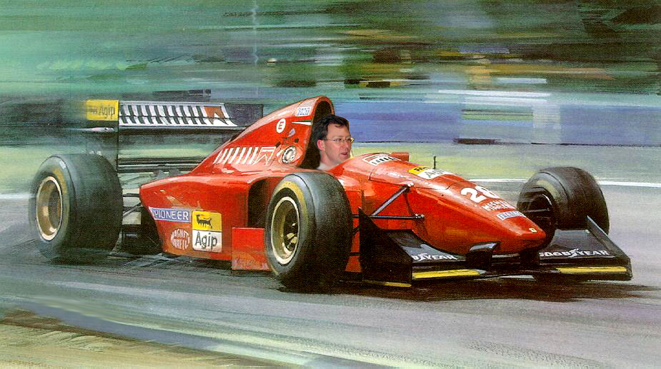
and once more…..

