Richard
&
Ishraq

happy

anniversary!

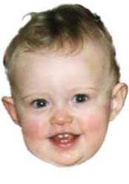
(We're glad you're having an anniversary too!)

