May all your hopes for the coming year
turn out to be
right on target!

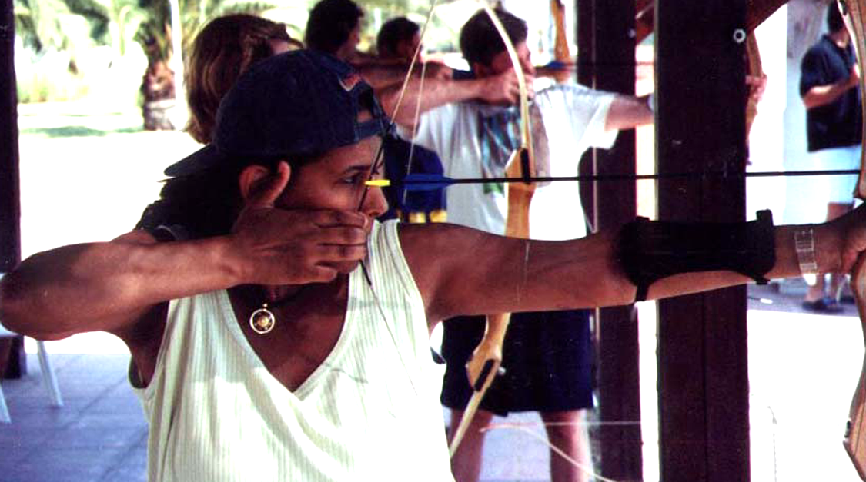

With much love,

