Arthur [with P&G, in Cincinnati]:
 | Arthur's life continues with his engineering career, working projects in P&G’s Product Development, and punctuated by occasional mini trips for business and pleasure. Highlights have been long weekends in Chicago for museum visits, New Orleans for jazz, blues, and spicy food, Orlando for a convention, skiing in California, Hilton Head to visit Mom & Dad at Thanksgiving, Pittsburgh to visit Peter and his family in their new house, and Port Clinton in northern Ohio for the National Rifle Championships.  Of course, the Riverfest weekend right here in Mt Adams, for which Arthur throws his annual watch-the-fireworks (and more) party was, as always, a big hit. His cat collection has remained stable - they manage the apartment while he’s gone, and help with typing on the klhjscvc computer whenever he’s home. |  | 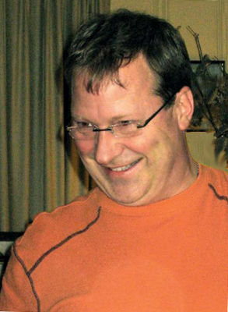
When Sue and family visited the US last summer, Uncle Art took Nick (11) to a machine shop, where they discovered they could make high-performance yoyos on a lathe. On the spot they decided to start a company to produce and sell them. Thus, with way big excitement, www.yoyoforge.com was born. Computer designs were sent to a Chinese fabricator and prototype samples were made.
Nick is developing a web page, pretty girls are being lined up to do demos; corporate officers have been appointed (ie, Sue, Jan Willem, and Arthur). Production is imminent.  [You may use the reverse side of this Christmas letter to order the number you need. Include your credit card info.] |  | 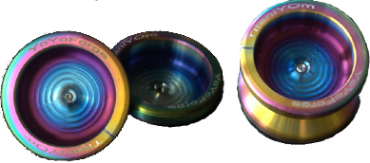

Richard and Ishraq (and Samer and Lila my favorite granddaughter) [currently en route, in stages, from Istanbul to Frankfurt]:

After four adventuresome and dynamic years in Istanbul as the general Manager of Reckitt-Benckiser’s subsidiary in Turkey Richard was named GM for Germany, one of the company's larger subsidiaries. The family is thrilled to move back to Europe where we’ll live in the Frankfurt area.  Unfortunately the international school in Frankfurt is full. Samer and Lila can’t be admitted until September, so will have to remain in the International School of Istanbul until then, forcing the family to live apart for eight months, adding to the stress of the move. | 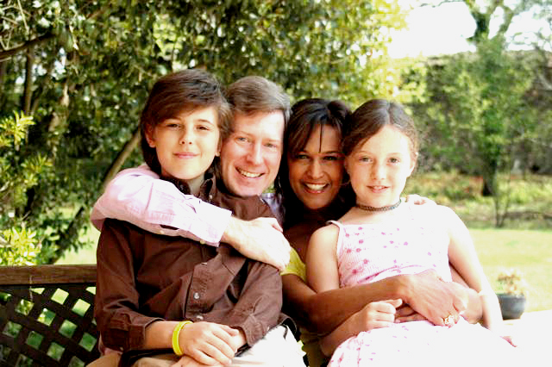
Aside from this speed bump, everyone is doing well. Ishraq is Vice Chairman of the school board and was until recently a board member of the International Women’s Club, in charge of Charity. She made a magnificent trip to Tibet, Nepal and Bhutan with a girlfriend this Fall.

The kids are also great. Samer is 13 and has started the frightful metamorphosis to teen-age-hood. Local police have been notified. He still enjoys creating computer animations, and plans to Change the World as an engineer. Lila is 11 and continues her love of art and piano. It's scary to us how a little kid can just sit down and play any complex classical song from sheet music when we can’t remember even three notes in a row. Coco, the chocolate lab, is now two, and is still a fun bouncy ball of fur.

As ever, the family continues to enjoy regular, beautiful holidays on the Red Sea in Egypt: diving, escapes on the Harley, island visits, and plenty of sun. These events, along with Family Christmas at grandma and grandpa's, are always the highlights of our year.
Peter and Cathy (and Steven and Alexander) [living in Pittsburgh; both with IBM]:
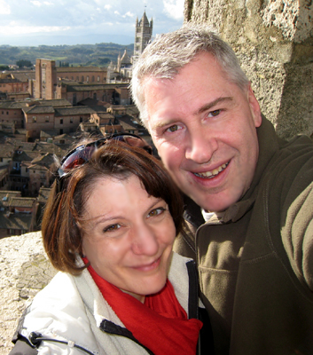 | BIG NEWS: We have moved – but we’ll get to that in a second.  The year began on a relatively calm note with Cathy on maternity leave. We spent a lovely month in Hilton Head where Pete managed to work remotely and find time to play tennis. Cathy spent her free time cycling and taking Alex for long walks. Steven came down to visit with Cathy’s mom and had fun playing on the beach. Perhaps the most memorable part of this trip was hosting a Superbowl party and watching our local Pittsburgh Steelers win the championship! | 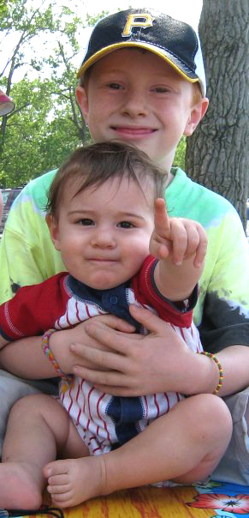
Cathy returned to work in February and Alex started daycare. We are all building our immune systems as he exposes us to every germ imaginable. Alex’s big accomplishments for the year include cruising (6-months), walking (11 months), basic words like ma-ma, da-da, ba-ba, dog-gie and duc-kie (12 months) and discovering how to get into everything (ongoing). His extracurricular activities this year included Kindermusik and Gymkhana classes. As he approaches the 16-month mark, he continues to develop new skills daily. A major influence on his development comes from his big brother, Steven, whom he adores and imitates constantly.

Steven (nine) continues to excel academically, as is evident from his placement in the advanced math and reading programs. He advanced one step closer to achieving his black belt in Tae Kwon Do. His extracurricular activities this year included tennis lessons, swimming lessons, soccer, basketball and cub scouts. When he is not studying or playing sports, he loves to spend time chasing his brother around in circles (over and over again).

Perhaps the biggest announcement is that we moved! After months of looking, we finally found a wonderful house in the Mt Lebanon section of Pittsburgh. We have already completed a number of home improvement projects and are making it feel like home.

Finally, work continues to go well for both us at IBM. We have both reduced our travel significantly – which is a good thing – although we did manage to escape to Italy to celebrate yet another anniversary of Cathy’s 29th birthday ☺

