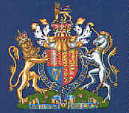

Don,

Happy Birthday

to a man whom
any queen…..

